Jack Wychor

Portfolio

short line

May 18th, 2020

# Projects

|  |  |
| --- | --- |
| **Project** | **Biggest Takeaways** |
| Manufacturing | How to:   * Create and code a training application in Unity using C#, SQL, and JSON * Lead a training project by delegating tasks, giving feedback, setting deadlines, and developing our next steps * Create lesson plans * Lead meetings with SMEs to obtain job information * Design a server layout for data storage and querying using SQL * Utilize augmented reality for effective training implementations * Create training videos * Create systems and templates that can be easily changed in an agile environment * Research and decide the types of hardware (e.g. computers, tablets) and software necessary for the project |
| DemoFest | * Present and explain to groups of people who may know nothing about augmented reality or coding * Won Best Immersive/Simulation Solution for the Dotson Training Project’s augmented reality |
| Marvin | * Building relationships with external clients and vendors * Machine learning and statistics in R * Data visualization in R |

# Manufacturing

A manufacturing company in Minnesota approached the OERG with a proposal to improve their employee training program. My team overhauled the current training system to a digital format in Unity and C#. Obtaining the necessary information required:

* Interviewing trainers and supervisors to obtain training content to provide for both trainees and trainers
* Creating a system for considering employees trained, trainers, or supervisors
* Writing testing information and information to checkoff when employees are trained
* Recording training videos of trainers explaining how to complete certain jobs
* Documenting a training guide
* Providing a train-the-trainer module to teach adult learning principles and expected teaching behaviors to new trainers
* Developing a training application with the purpose of
  + Providing training information for trainees
  + Providing training information for trainers
  + Linking trainees to instructional videos and pictures
  + Providing a platform for trainees to take knowledge tests to find learning gaps
  + Updating server information when trainees become trained on topics

As the leader of the project, I was also responsible for:

* Organizing weekly team meetings
* Communicating with the client to ensure we were meeting their needs. This included personnel from:
  + Plant floor supervisors and trainers
  + IT department
  + Business Leaders
* Deciding what hardware, software, application layouts, and server layouts were necessary for the project
* Creating templates of these designs for future use by other people
* Teaching team members how to use the templates and code I had built for the application



*Figure 1.* *An example of a Learning Module I developed for the manufacturing company. Note: Proprietary Information has been Censored.*



# DemoFest 2019

In the fall of 2019, I presented a project, *Augment Reality in Manufacturing* based on the manufacturing project described previously at DemoFest, a conference in Las Vegas. This project was focused on augmented reality and creating a user interface that employees could use to quickly learn how to use each button on a machine. The project was wildly popular and won *Best Immersive/Simulation Solution*.

*Figure 2. An Example of the Augmented Reality Application Highlighting Buttons*

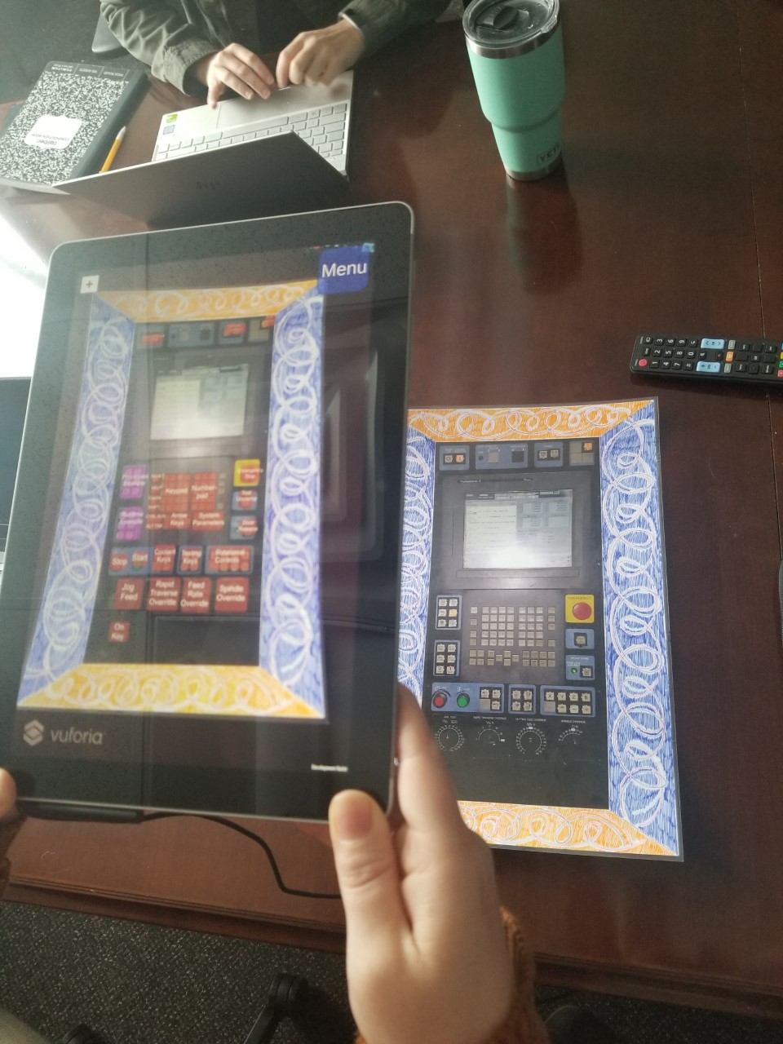

# Marvin

Over the Summer of 2019, I spent 3 months at Marvin Windows and Doors as a Talent Management Intern. Our team was in charge of helping choose from 3rd party employee engagement survey vendors and presenting our findings to HR leaders. We also conducted market research on Paid Time Off policies and presented them to HR leaders similar to the 3rd party vendors. Finally, I used machine learning algorithms to summarize and visualize employee comment data that was otherwise infeasible read through using R and Tableau.

*Figure 3. Data Visualization Example*

